**Multiple Linear regression with Scikit-Learn :**

**Note : In Linear regression we work with one independent variable ..**

**But Now in Multiple regression we work with multiple variables ..**

**(1) Import our dataset :**

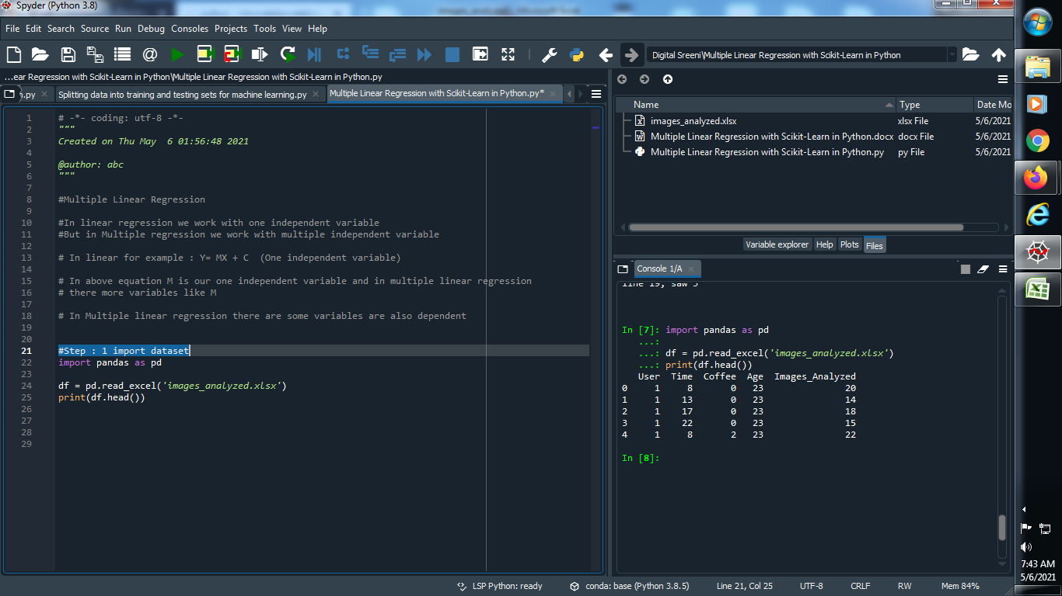

**Output :**



**(2) Plot this dataset :**

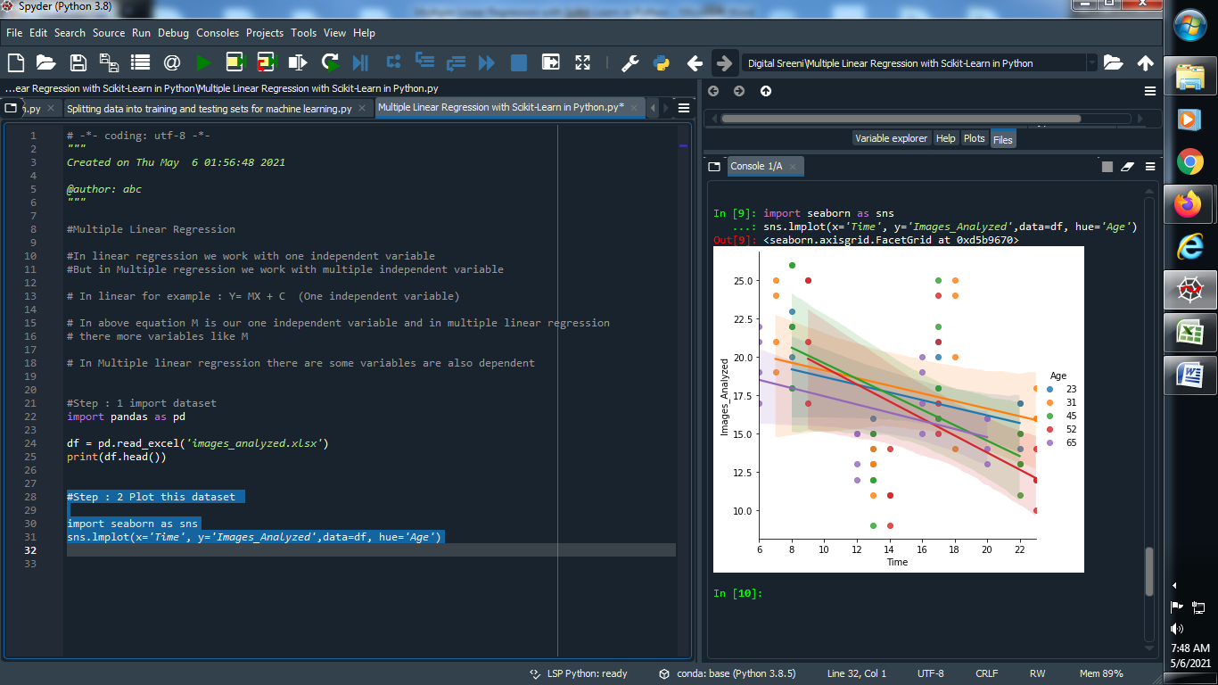

**Output :**



**(3) Plot our dataset for different value of x**

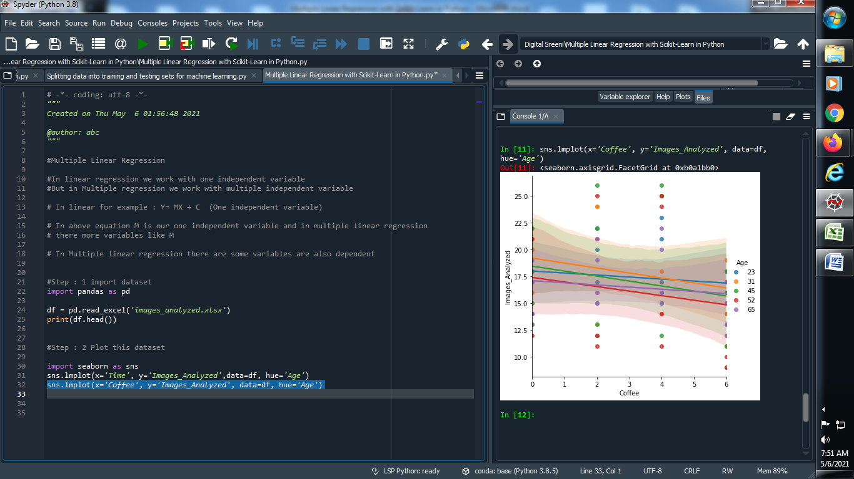

**Output :**



**(4) Predict our Multi Linear Regression :**

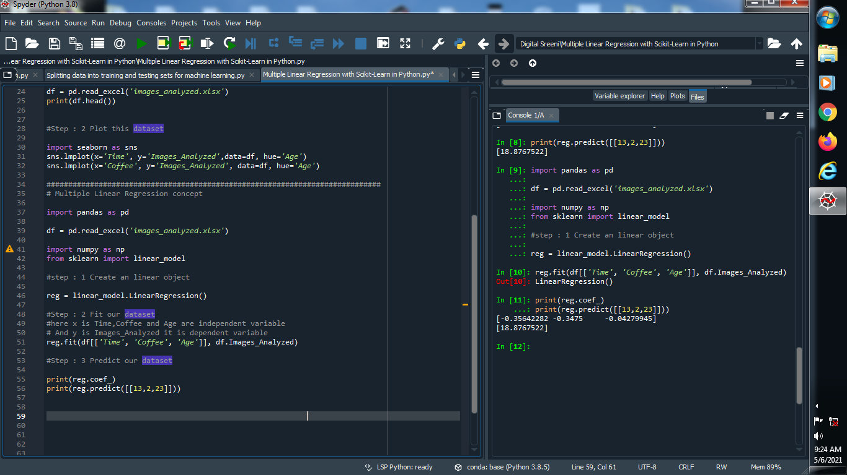

**Output :**

